**CS 340 PROJECT TWO README**

## Functionality

Graviosos Salvares dashboard helps gives users certain data types regarding the recuse animal files in the database animal shelter. It list everything they need within categories like water rescue, mountain or wilderness rescue, and disaster or individual tracking. This lets users really narrow down what they are looking for within the datafile. The graphs helps the users visually see the data instead of just reading numbers about the data. The pie chart shows, the breed and geolocation, also ages. 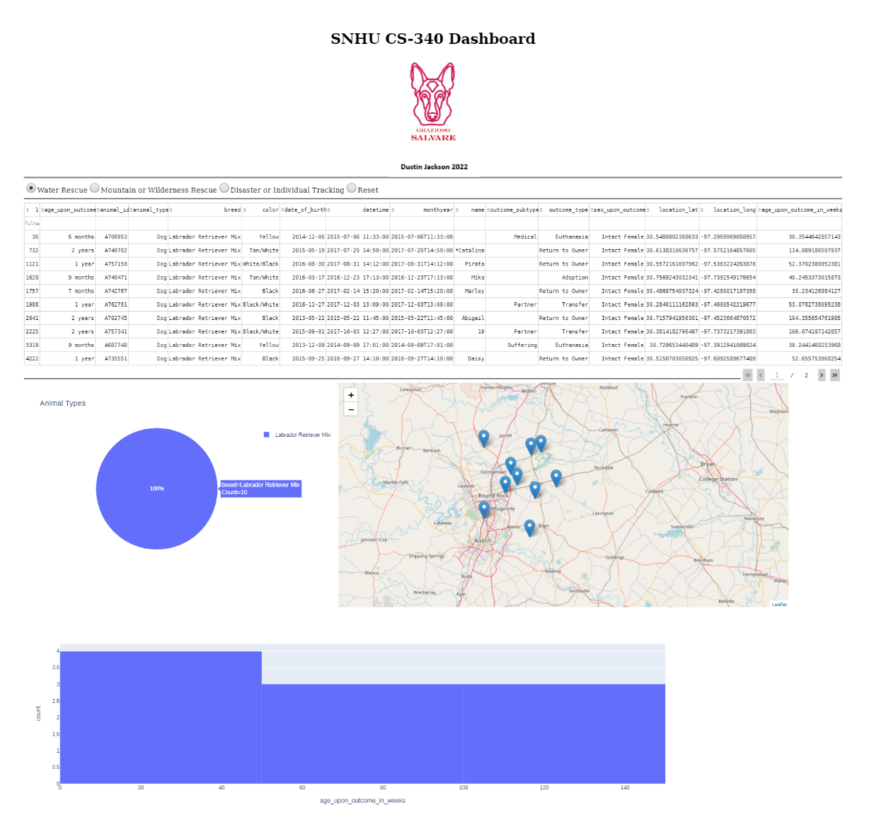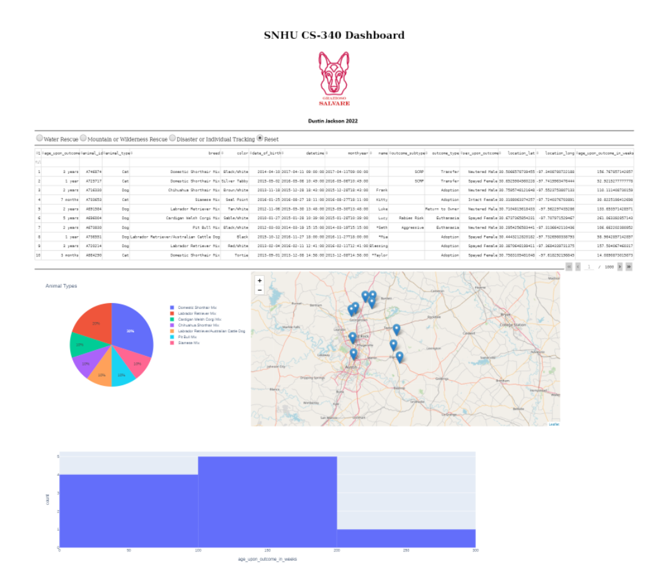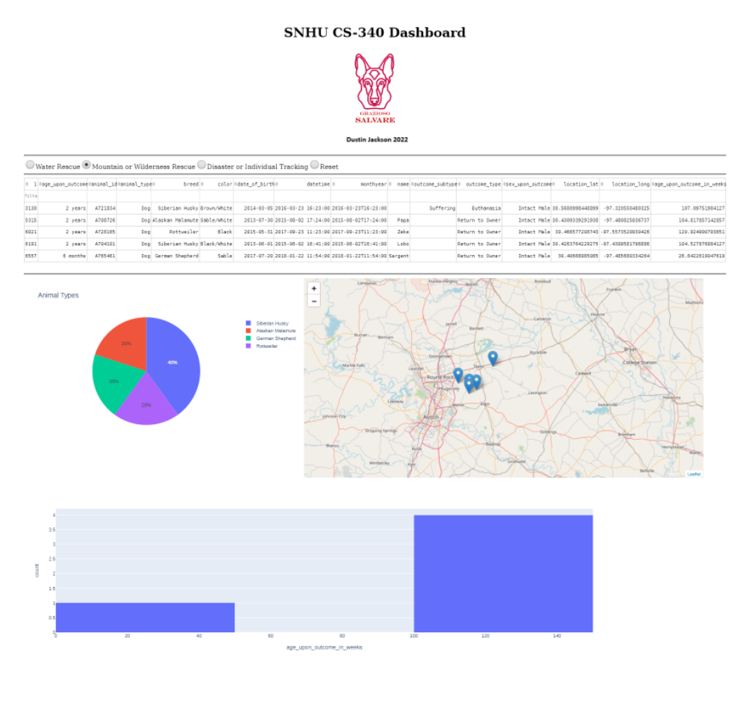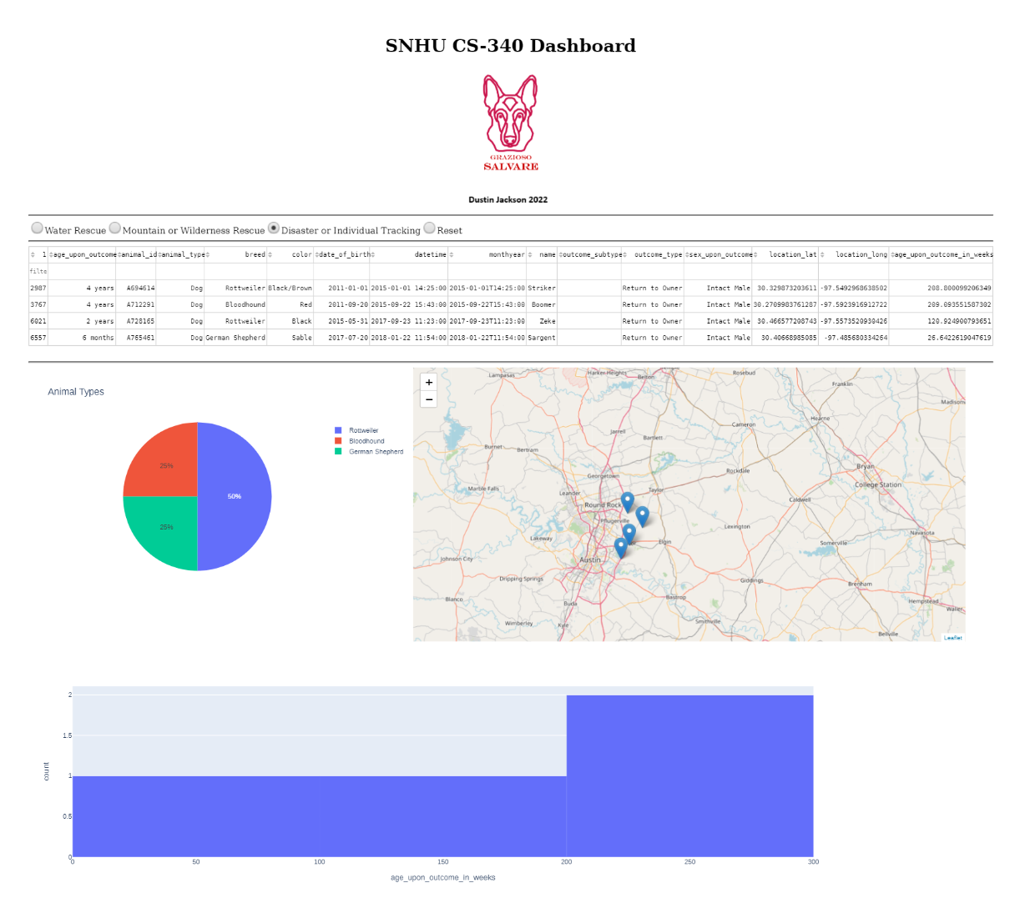

**Tools**

**Python**: is the programming language that this was written in, lots of variables and the correct syntax was needed for this to work properly.

**Dash**: a framework was needed to incorporate certain features to interact with web-based functions

**Jupyter Notebook**: this was an IDE that was used to write the python code test procedures and the main functions methods and was used to get the results.

**MongoDB**: This was used to store the documents and collections for the assignments and kept everything organized when it came to the CRUD method.

**Steps**

The first step I took was importing the correct documents into the mongo platform. This is the most important step because python needs to know what documents they are implementing the crud method. Another important step was writing the crud method in order to create, read, update, and delete functions so that mongoDB can handle it. Then I needed to make sure everything was authenticated and that users credentials worked sufficiently in the mongoDB platform. The next step was the front end application process this was used with dash and then some buttons where needed to filter through the databases.

**Challenges**

The main challenge I came across was using the dash to get the front web application working properly. I found it difficult to learn how to get it to run successfully with in the database from mongo. But I was able to get it up and running smoothly. Another challenged I face was actually the crud method, I kept having to refer back to the documents provided when it came to the delete function.

## Contact

Dustin Jackson Jr